UBER REQUEST DATA INSIGHTS
Project Name: Uber Request Data
Contribution: Individual
Name: Anjali Mishra
Project Summary
This project involved performing an Exploratory Data Analysis (EDA) on Uber cab request data to understand ride patterns, identify operational challenges, and suggest improvements in Uber’s cab allocation strategy. The dataset comprised timestamps of ride requests, pickup points (City or Airport), driver IDs, and trip statuses (Trip Completed, Cancelled, or No Cars Available).
We began by cleaning and preprocessing the data. The timestamps were converted into datetime format and new time-based features such as ‘Request Hour’ and ‘Request Day’ were extracted. Missing values were handled in the ‘Driver ID’ and ‘Drop timestamp’ columns, which were mostly missing in cancelled or unfulfilled trips. Visualizations were used to understand the distribution of request statuses, pickup locations, and time of day.
Key Insights
1. Data Preprocessing
- - Converted timestamps to datetime format.
- Extracted ‘Request Hour’ and ‘Request Day’ features.
- Handled missing values in 'Driver ID' and 'Drop timestamp'.
2. Univariate Analysis
- - Majority of ride requests originated from City.
- Large proportion of requests were either cancelled or unfulfilled.
- Only a portion of all requests were successfully completed.
3. Bivariate Analysis
- - Early morning (5 AM – 9 AM): High cancellation rate from the city.
- Evening (5 PM – 9 PM): Airport requests often showed “No Cars Available”.
- These periods show the highest supply–demand gaps.

Insights from Excel Dashboard (Uber Request Data)
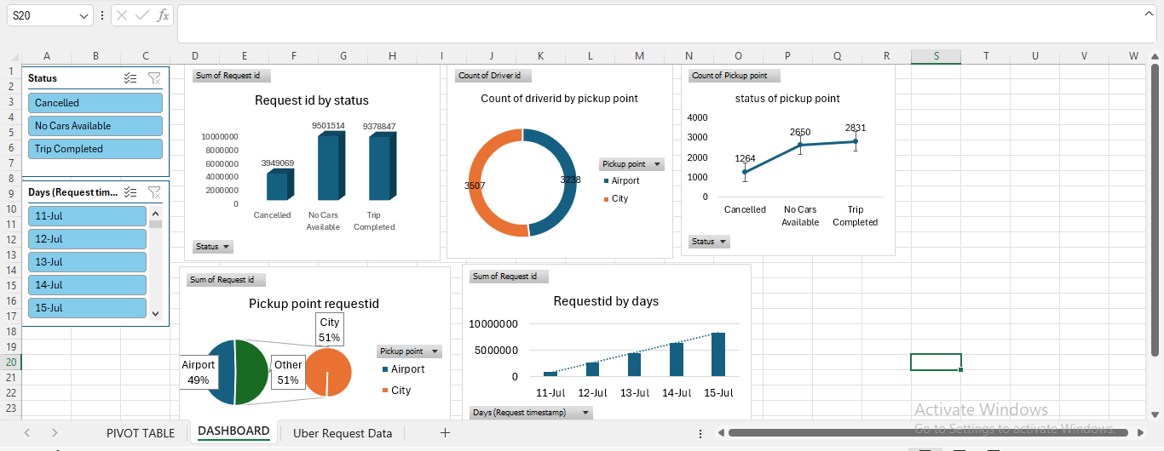
- Trip Status Summary:
“No Cars Available” and “Trip Completed” counts are almost equal (~95 lakh), while “Cancelled” is much lower (~39 lakh). Indicates that demand was high, but many requests couldn’t be served.
- Driver Distribution by Pickup Point:
Slightly more drivers served City (51%) compared to Airport (49%). Balanced distribution, but not enough to meet full demand at both locations.
- Status by Pickup Point:
Airport has higher “No Cars Available” cases, City has more cancellations. Uber needs more drivers at Airport during peak times and must address why users cancel in City.
- Request Trend by Days:
Requests consistently increased from 11 July to 15 July. Suggests growing demand, and Uber should prepare for higher traffic in future.
- Pickup Point Requested:
City and Airport requests are almost equal (51% vs 49%). Service issues at either location will impact overall business.

Insights from SQL Analysis (Uber Data)
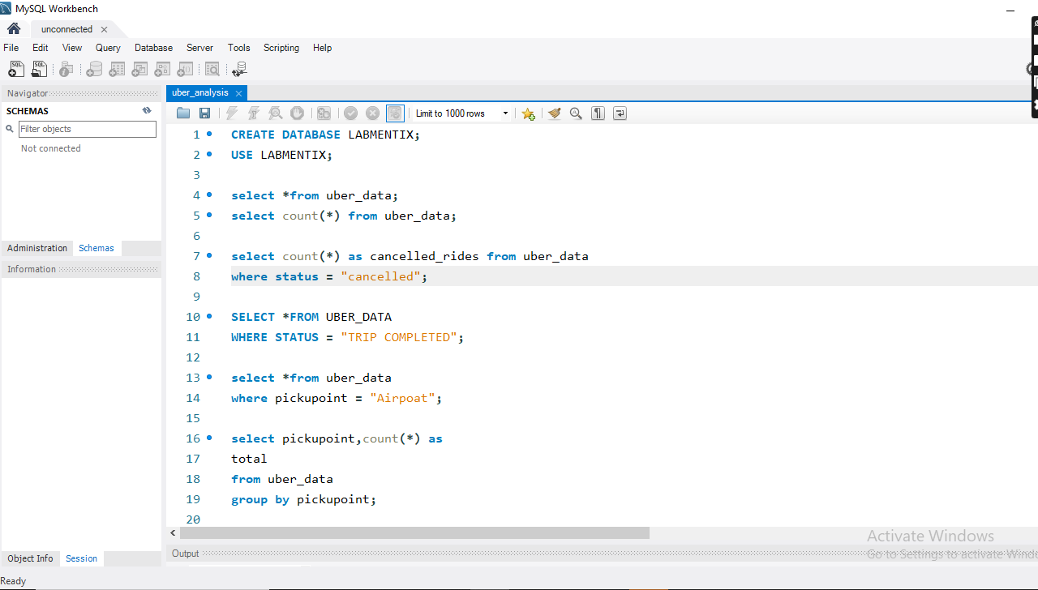
- Most Requests from City:
Majority requests are made from the City side.
- High Unavailability at Airport:
Airport suffers most from driver shortage.
- Cancelled Trips by Time:
Maximum cancellations between 5–9 AM and 5–9 PM. These are rush hours, and driver supply isn't matching user demand.
- Trip Completion Rate:
Success rate is decent but leaves a large gap in service delivery.
- Peak Dates Identified:
15th July had the highest number of requests, which matches the Excel chart. This validates your dashboard and supports business planning.

